ABSTRACT
Streetlights are a basic civic utility, and their failure directly affects public safety, visibility and the general sense of upkeep in a neighbourhood. At present, most residents report a faulty streetlight through a phone call, or an in-person visit to the ward office, a process that is slow, undocumented and gives the citizen no way to track whether, or when, the fault will be fixed.

This project presents CivicLight, a web-based Streetlight Fault Reporting System that allows citizens to report a malfunctioning streetlight by submitting a photograph of the fault along with its precise GPS location. Each report is converted into a trackable ticket and placed on a live administrator dashboard, where municipal staff can view every open complaint across the city, update its status, and leave remarks that are visible to the citizen who raised it. The system supports two distinct, role-based logins — Citizen and Administrator — and keeps both sides synchronised in real time, so that a new report appears on the administrator's dashboard immediately, and every status change is reflected back on the citizen's own tracker without either party needing to follow up manually.

By replacing an opaque, manual complaint process with a transparent, accountable digital workflow, CivicLight aims to reduce the average turnaround time for streetlight repairs and improve citizen trust in civic maintenance.

Keywords: Streetlight fault reporting, civic complaint management,
GPS geotagging, e-governance, citizen engagement, smart city.

TABLE OF CONTENTS
DECLARATION I
ACKNOWLEDGEMENT II
ABSTRACT 1
TABLE OF CONTENTS 2
LIST OF FIGURES 4
CHAPTER 1 INTRODUCTION 5
1.1 Overview 5
1.2 Problem Statement 5
1.3 Objectives 5
1.4 Scope of the Project 6
1.5 Organization of the Report 6

CHAPTER 2 LITERATURE SURVEY 7
2.1 IoT-Based Automatic Fault Detection Systems 7
2.2 Mobile and Web-Based Civic Complaint Platforms 7
2.3 Case Study: BBMP Sahaaya, Bengaluru 7
2.4 Summary and Research Gap 8

CHAPTER 3 SYSTEM ANALYSIS 9
3.1 Existing System 9
3.2 Limitations of the Existing System 9
3.3 Proposed System 10
3.4 Feasibility Study 10
3.5 Hardware Requirements 10
3.6 Software Requirements 11
3.7 Functional Requirements 11
3.8 Non-Functional Requirements 11
CHAPTER 4 SYSTEM DESIGN 12
4.1 System Architecture 12
4.2 Data Flow Diagrams 13
4.3 Database Design 14
4.4 UML Diagrams 15
4.5 User Interface Design 16

CHAPTER 5 SYSTEM IMPLEMENTATION 17
5.1 Development Environment 17
5.2 Technology Stack 17
5.3 Module Description 17
5.4 Key Implementation Details 18
5.5 Database Implementation 18

CHAPTER 6 RESULTS AND DISCUSSION 19
6.1 Testing 19
6.2 Sample Outputs 19
6.3 Discussion 21

CHAPTER 7 CONCLUSION AND FUTURE WORK 22
7.1 Conclusion 22
7.2 Future Enhancements 22

REFERENCES 23

LIST OF FIGURES

Fig No. Name Page No.
3.1 Existing (Manual) Complaint Workflow 9
4.1 System Architecture Diagram 12
4.2 Data Flow Diagram — Level 0 13
4.3 Data Flow Diagram — Level 1 13
4.4 Use Case Diagram 15
4.5 Database Schema / Entity-Relationship Diagram 14
4.6 Sequence Diagram — Fault Report Submission 15
6.1 Citizen Dashboard 19
6.2 Report a Fault — Form View 20
6.3 Administrator Dashboard 20
6.4 Complaint Detail and Status Update View 21

CHAPTER 1
INTRODUCTION
  - Overview
Streetlights are one of the most visible forms of civic infrastructure, directly influencing night-time safety, road accident rates and the perceived liveability of a neighbourhood.
Municipal bodies are responsible for maintaining thousands of streetlights across a city, and faults are typically discovered only when a resident notices a dark pole and chooses to report it — usually by phone, in person, or through a general-purpose grievance portal where the specific details needed for repair (exact pole location, nature of the fault, photographic evidence) are often missing or vague.

This project proposes CivicLight, a purpose-built web application that let’s citizens report a streetlight fault in under a minute, using their device's camera and GPS, and lets administrators manage every report from a single, live dashboard.

  - Problem Statement
"Develop an application for citizens to report faulty streetlights using photographs and GPS locations."

Specifically, the following gaps were identified in the current, largely manual reporting process:
- No structured channel exists for citizens to submit a complaint together with photographic
evidence of the fault.
- Citizens have no way to track the status of a complaint once it has been filed.
- Administrators lack a centralised, real-time view of all open faults across their jurisdiction.
- Repairs are frequently delayed because the complaint does not include an exact,
verifiable location.

  - Objectives
1. Enable citizens to report a streetlight fault using a photograph and GPS location.
2. Provide secure, role-based login for two distinct user types — Citizen and Administrator.
3. Centralise every complaint raised by any citizen on a single, live administrator dashboard.
4. Allow a complaint's status to be tracked from submission through to resolution (Submitted, In Progress, Resolved, Rejected).
5. Improve transparency and accountability in civic maintenance by keeping both citizen and administrator synchronised in real time.
6. Reduce the average turnaround time for streetlight repairs.

  - Scope of the Project
The system covers the complete citizen-to-resolution workflow for streetlight faults: account creation and login, fault reporting with photo and GPS capture, live status tracking by the citizen, and centralised complaint management (viewing, filtering, searching, status updates and remarks) by the administrator. It does not cover automatic hardware-based fault detection (e.g. IoT sensors on the streetlight itself) or the dispatch and field-tracking of repair crews, both of which are identified as future work in Chapter 7.

1.5 Organization of the Report
Chapter 2 reviews related work in automatic streetlight fault detection and civic complaint-reporting systems. Chapter 3 analyses the existing manual process and derives the requirements for the proposed system. Chapter 4 presents the system architecture, data flow and database design. Chapter 5 describes the implementation in detail, module by module. Chapter 6 presents the testing carried out and the resulting outputs. Chapter 7 concludes the report and outlines future enhancements.

CHAPTER 2
LITERATURE SURVEY
2.1 IoT-Based Automatic Fault Detection Systems
A significant body of work addresses streetlight fault detection through dedicated hardware rather than citizen reporting.
Maheswaran et al. [3] propose a centralized monitoring system that uses sensor nodes on each streetlight pole to detect faults and report both the fault and its location to a central server, removing the need for a citizen to notice and report the issue at all.
Varghese et al. [4] present an energy-efficient smart street lighting system that combines automatic fault detection with real-time monitoring, focusing on reducing energy consumption alongside maintenance.
Chowdhury et al. [5] describe an IoT-based streetlight controlling and monitoring system for smart cities in Bangladesh, which performs real-time error detection using connected sensors and a central dashboard.
These systems are effective where the budget exists to instrument every pole with sensors and connectivity hardware, but such hardware rollouts are capital-intensive and slow to scale across an entire city. They also do not capture citizen-reported context (e.g. "light flickers only at night" or "pole is leaning dangerously") that a photograph and description can convey.

2.2 Mobile and Web-Based Civic Complaint Platforms
A parallel line of work focuses on citizen-facing software rather than hardware.
Shama, Aziz and Deya [6] present CitySolution, an Android application that lets citizens report a range of municipal issues by photographing them, with a deep-learning model used to auto-categorise the complaint and a separate authority-facing application to track and resolve it.
Similar systems reviewed during this survey (e.g. mobile complaint-monitoring applications built for municipal corporations) consistently combine three elements: a citizen-facing reporting interface, GPS-based location capture, and an administrator-facing dashboard for tracking and resolution — the same three-part structure adopted in this project.

2.3 Case Study: BBMP Sahaaya, Bengaluru
Sahaaya [7] is the Bruhat Bengaluru Mahanagara Palike's own citizen grievance redressal platform, and streetlight complaints are consistently among its highest-volume categories. Press reporting on the system notes both its value — citizens can upload photographs and track a complaint to resolution — and its recurring weaknesses: complaints are sometimes closed by field engineers without the underlying issue being fixed, and citizens have limited visibility into why a complaint remains open. This real-world precedent confirms both the demand for a structured, photo-and-location based reporting channel, and the importance of a genuinely transparent status/remarks workflow, which this project treats as a core design requirement rather than an afterthought.

2.4 Summary and Research Gap
Hardware-based systems (2.1) offer fast fault detection but are expensive to deploy at scale and cannot capture citizen context. Citizen-reporting platforms (2.2, 2.3) are cheaper to deploy and leverage the city's own residents as sensors, but existing deployments are often let down by weak status tracking and limited administrator visibility. CivicLight is positioned in this second category and specifically addresses the transparency gap by giving every complaint a persistent status timeline that both the citizen and the administrator can see, rather than a complaint that is simply opened and silently closed.

CHAPTER 3
SYSTEM ANALYSIS
3.1 Existing System
Streetlight faults are currently reported through one or more of the following channels: a telephone helpline, an in-person visit to the ward/zonal office, or a general-purpose municipal grievance portal (e.g. BBMP Sahaaya, Section 2.3) that handles many unrelated complaint categories alongside streetlights.
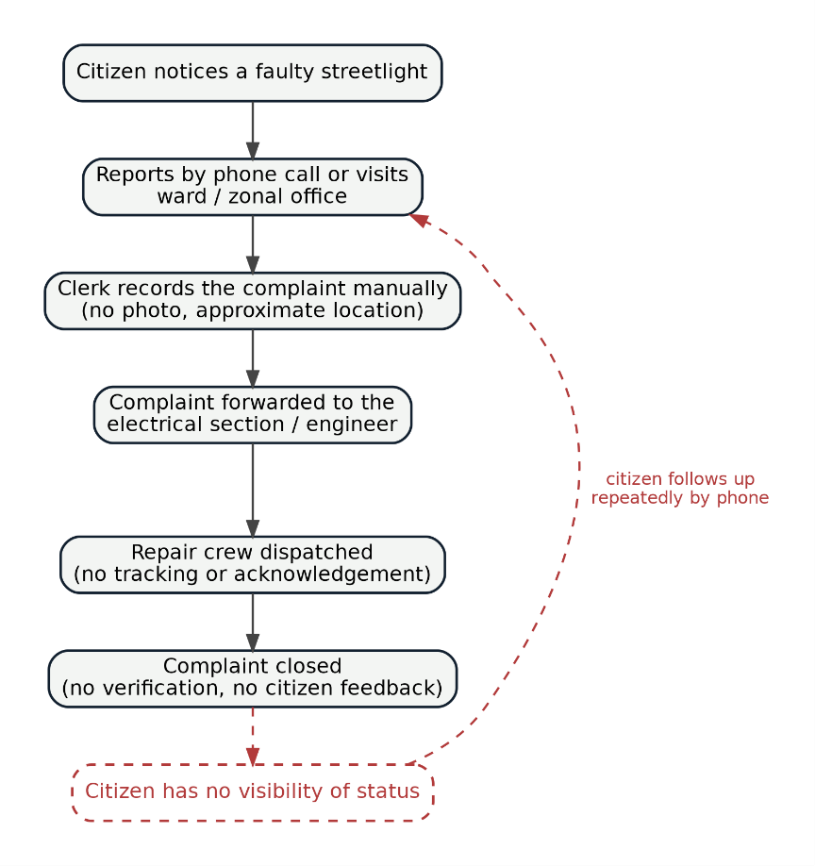
Fig. 3.1 Existing (Manual) Complaint Workflow

3.2 Limitations of the Existing System
- Complaints filed by phone or in person are rarely accompanied by photographic evidence or exact GPS coordinates.
- Citizens have no dedicated, real-time way to check a complaint's status.
- Complaints are sometimes marked "resolved" without verification, with no visible history for the citizen to dispute this.
- Administrators handling a general-purpose grievance portal have no streetlight-specific view (e.g. open-for-7+-days flagging).
3.3 Proposed System
CivicLight is proposed as a dedicated, role-based web application with two portals:
- A Citizen Portal where a registered citizen can submit a new fault report (category, description, a required photograph and a GPS location captured via the browser) and track every report they have filed through a status timeline.
- An Administrator Portal where a logged-in administrator sees a live, searchable and filterable table of every complaint raised by every citizen, can open any complaint to view its full detail, and can update its status while leaving a remark that is immediately visible to the citizen.
Both portals stay synchronised in real time through a shared backend, so a new submission appears on the administrator's dashboard without a page refresh, and a status update appears on the citizen's tracker just as instantly.

3.4 Feasibility Study
Technical Feasibility: The system uses only standard, well-supported browser technologies (HTML5, CSS3, JavaScript, the Geolocation API and the File API) on the client side, and a cloud-hosted real-time database and object store on the server side, making it technically feasible to build and run without specialised infrastructure.
Economic Feasibility: As a web application with no dedicated hardware requirement, the system avoids the capital cost associated with sensor-based alternatives (Section 2.1), making it an economically feasible pilot for a ward-level rollout.
Operational Feasibility: The citizen-facing workflow requires only a smartphone or computer with a camera, GPS and a web browser — hardware that is already in widespread use — and the administrator workflow mirrors the dashboards municipal staff already use for other grievance categories, minimising the learning curve.

3.5 Hardware Requirements
Component | Purpose
Citizen's smartphone / PC (with camera and GPS) | Capture photo evidence and location of the fault
Administrator's desktop / laptop | Access and manage the live complaints dashboard
Internet connectivity | Required for both citizens and administrators
Cloud server infrastructure | Hosts the application, database and uploaded photographs
3.6 Software Requirements
Layer | Technology
Frontend | HTML5, CSS3, JavaScript (ES6)
Data layer | Real-time NoSQL cloud document database
Media storage | Cloud object storage for uploaded photographs
Browser APIs | Geolocation API, File / Camera API
Internet connectivity | Role-based email and password login (Citizen / Administrator)
Cloud server infrastructure | Modern web browser — Chrome, Firefox or Edge

3.7 Functional Requirements
1. | The system shall allow a citizen to create an account and log in.
2. | The system shall allow a citizen to submit a fault report with a category, description, a required photograph, and a GPS location (or a manual fallback when GPS is unavailable).
3. | The system shall generate a unique ticket number for every report.
4. | The system shall allow a citizen to view the real-time status of every report they have filed.
5. | The system shall allow an administrator to log in through a separate, role-restricted login.
6. | The system shall display every complaint from every citizen on a single administrator dashboard, with search and filter by status and category.
7. | The system shall allow an administrator to update a complaint's status and add a remark visible to the citizen.
8. | The system shall flag complaints that have remained open for more than seven days.

3.8 Non-Functional Requirements
1. | Usability | The interface shall be simple enough for a first-time citizen user to submit a report without instructions.
2. | Performance | New reports and status updates shall propagate to the relevant dashboard within a few seconds.
3. | Security | Passwords shall be hashed before storage; access to each role's data shall be restricted by login.
4. | Availability | The system shall be accessible from any modern browser without additional software installation.
5. | Scalability | The data layer shall support a growing number of citizens and complaints without redesign.

CHAPTER 4
SYSTEM DESIGN
4.1 System Architecture
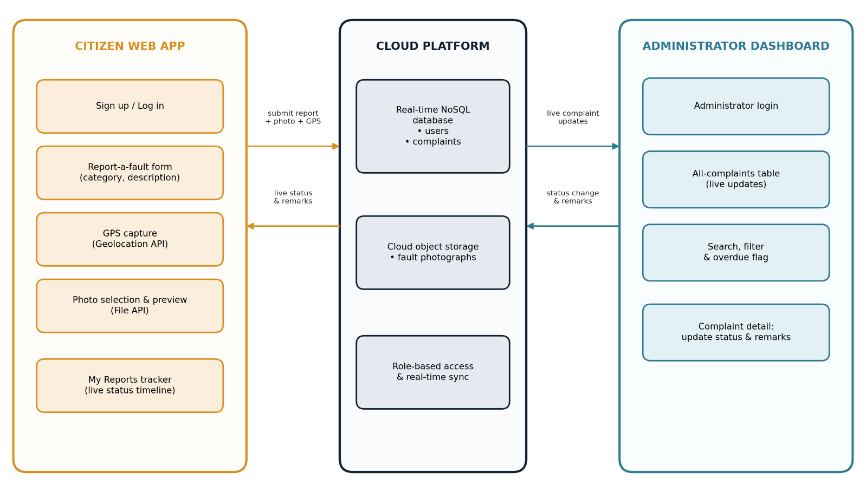
Fig. 4.1 System Architecture Diagram
The system follows a simple three-part architecture:
- Citizen Web App — the interface through which a citizen reports a fault (category, description, photo, GPS location) and tracks their own reports.
- Cloud Database and Photo Storage — a real-time, role-secured store that holds user accounts, complaint records and uploaded photographs, and pushes updates to both portals as soon as data changes.
- Administrator Dashboard — the interface through which an administrator views, filters and updates every complaint in the system.
Data flows in both directions: every new report flows from the Citizen Web App into the shared store and out to the Administrator Dashboard; every status update flows from the Administrator Dashboard into the shared store and back out to the citizen's own tracker.

4.2 Data Flow Diagrams
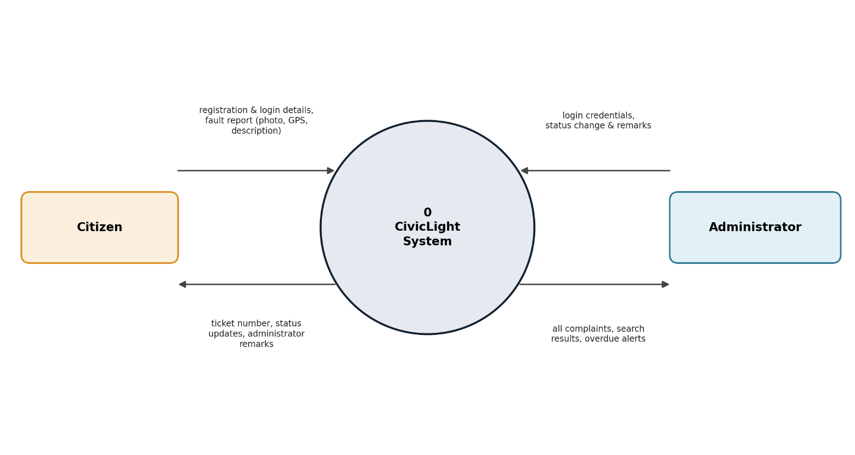
Fig. 4.2 Data Flow Diagram — Level 0
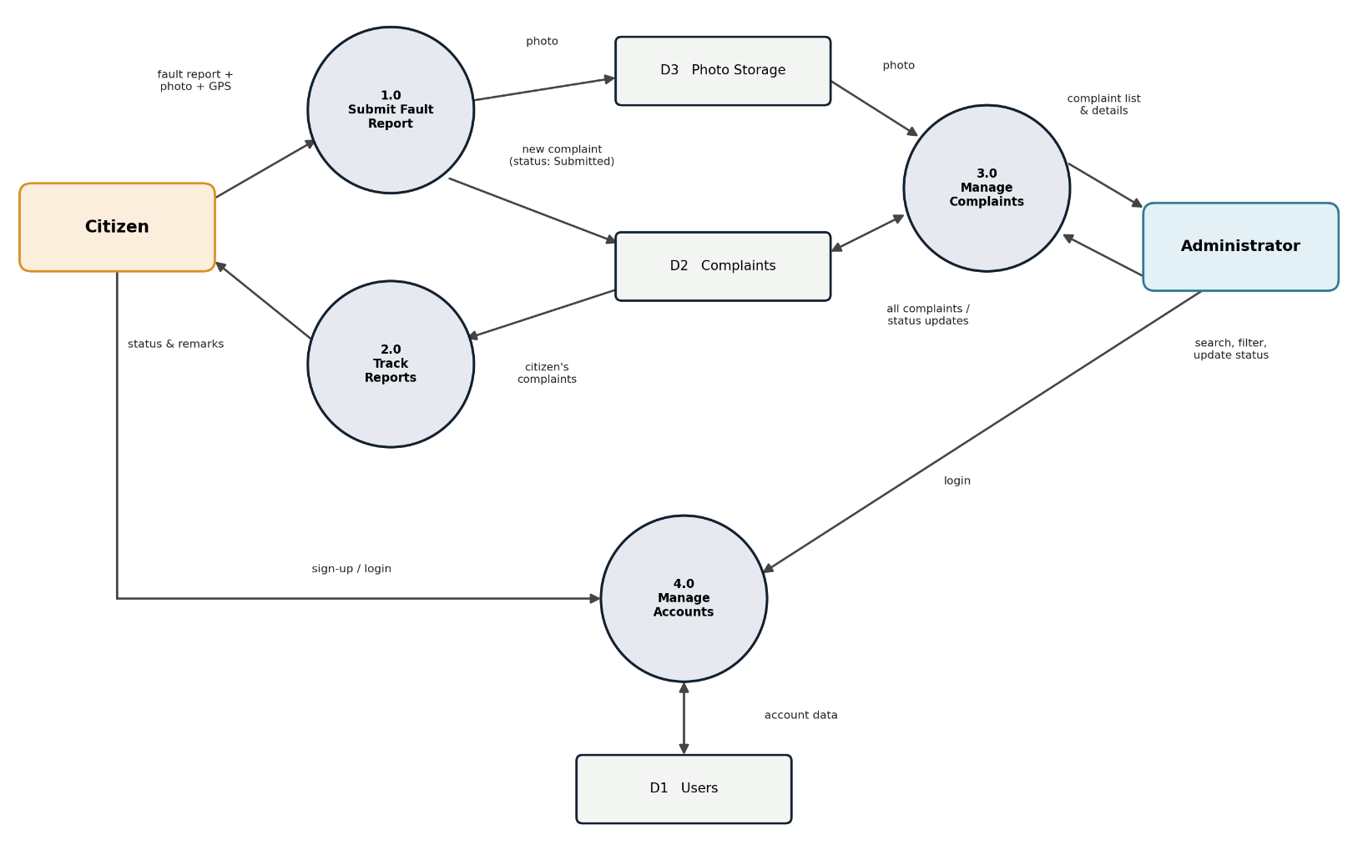
Fig. 4.3 Data Flow Diagram — Level 1
4.3 Database Design
(See Figure 4.5.) The system uses two primary data collections:
Users:
Field | Description
name | Full name of the user
email | Login email (unique)
phone | Contact phone number
address | Ward / area (citizens only)
role | "citizen" or "admin"
passwordHash | SHA-256 hash of the account password
createdAt | Account creation timestamp

Complaints:
Field | Description
ticketNo | Unique, human-readable ticket code (e.g. CL-2026-9F3A)
citizenId, citizenName, citizenEmail | Reference to the reporting citizen's user record
citizenPhone | Reporting citizen's contact details
category | Fault category (e.g. Lamp not lighting, flickering light, Broken or leaning pole, Exposed wiring, Light on during daytime, Other)
description | Citizen's description of the fault
landmark | Free-text landmark / address, if provided
location | {lat, lng, accuracy, source} captured via the Geolocation API, or entered manually
photoAssetId | Reference to the uploaded photograph
status | Submitted / In Progress / Resolved / Rejected
adminRemarks | Administrator's note to the citizen
history | Ordered list of status changes, each with a timestamp and note, forming the status timeline
createdAt, | Timestamps
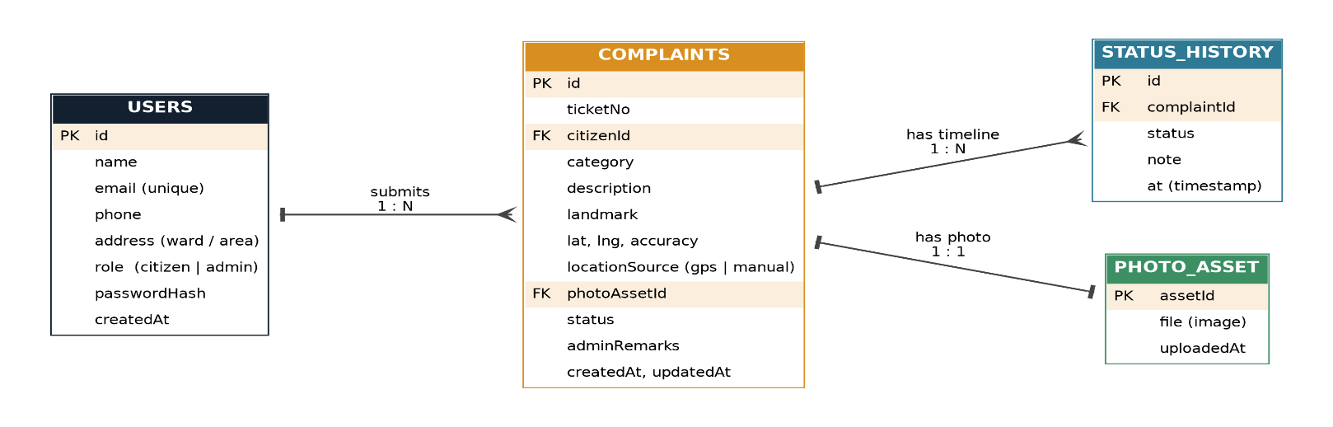
Fig. 4.5 Database Schema / Entity-Relationship Diagram
4.4 UML Diagrams
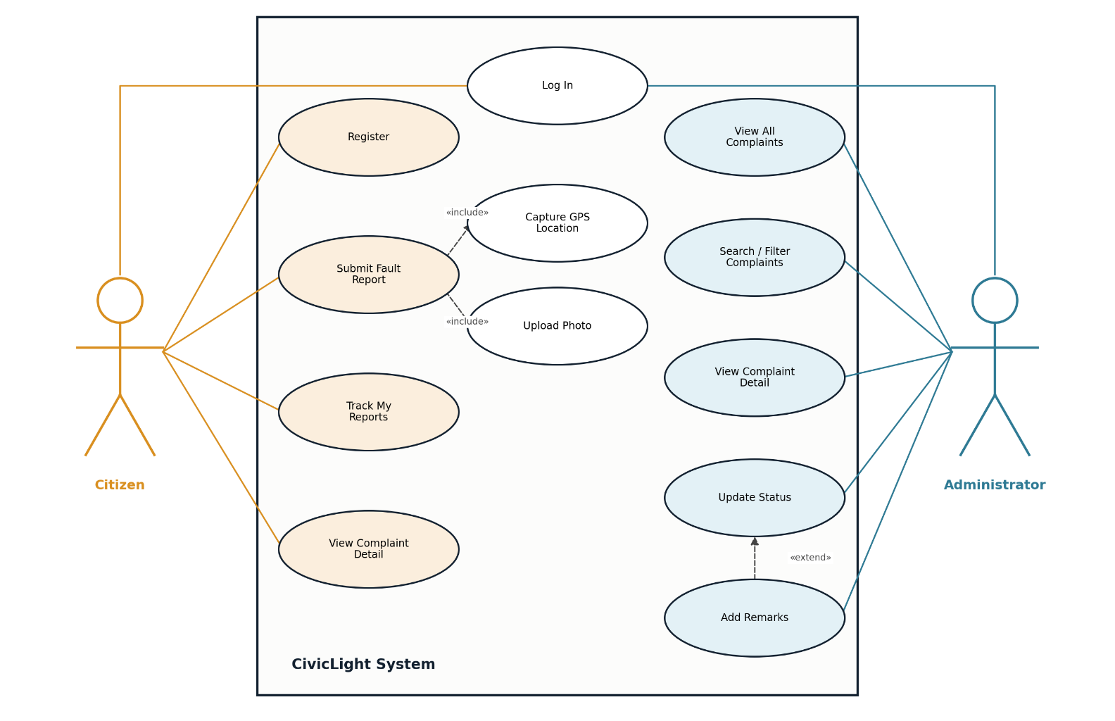
Fig. 4.4 Use Case Diagram
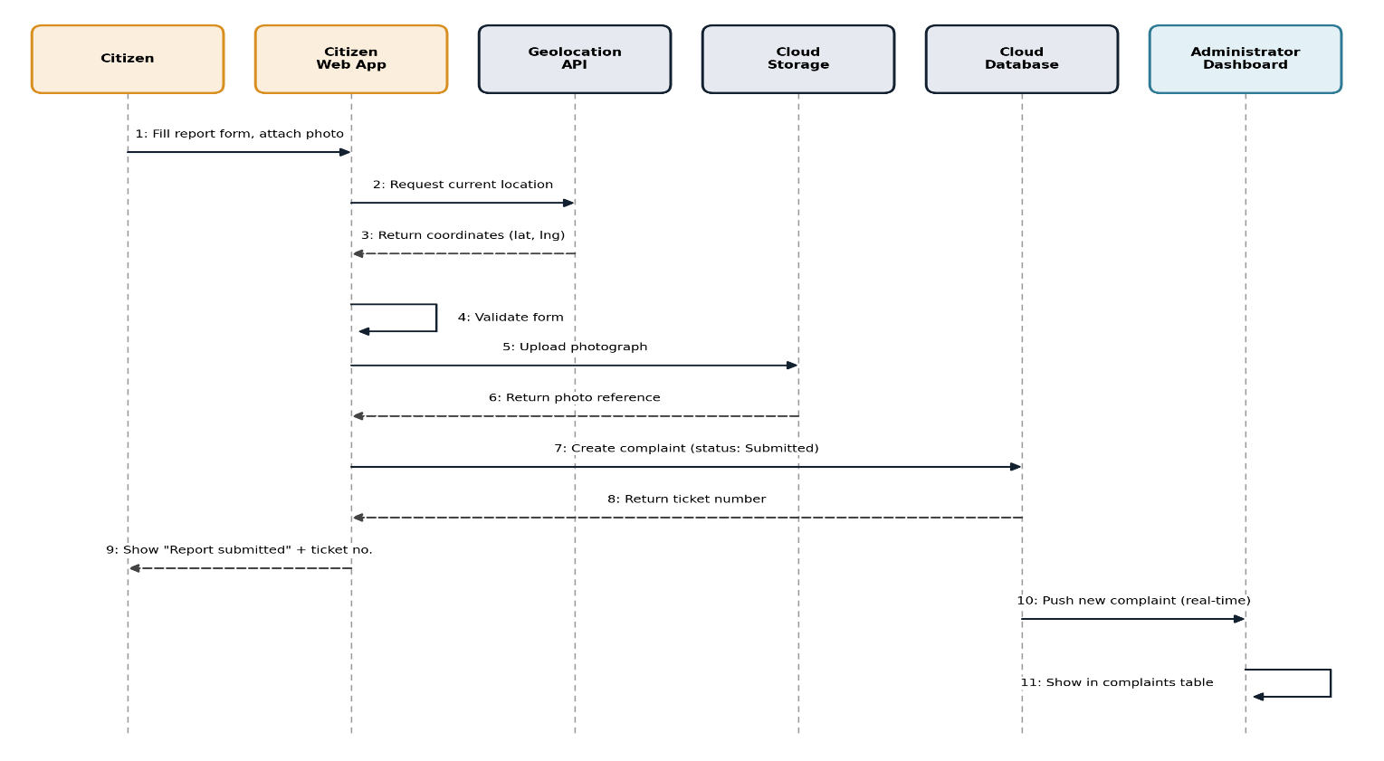
Fig. 4.6 Sequence Diagram — Fault Report Submission
4.5 User Interface Design
The interface follows a consistent visual identity across both portals: a navy-and-amber colour scheme evoking a streetlight's glow at night, with status indicated throughout via colour-coded badges (e.g. blue for Submitted, amber for In Progress, green for Resolved, red for Rejected) so that both citizens and administrators can scan a list of complaints at a glance. (See Figures 6.1 - 6.4 for representative screens.)

CHAPTER 5
SYSTEM IMPLEMENTATION
5.1 Development Environment
The system was implemented as a single-page web application, built and tested in a modern web browser, with a cloud-hosted real-time database and file storage backend.

5.2 Technology Stack
- Frontend: HTML5, CSS3 and vanilla JavaScript (ES6), chosen to keep the application self-contained and dependency-free.
- Data layer: a real-time NoSQL document database, which pushes changes to every connected client automatically (removing the need for citizens or administrators to manually refresh the page).
- Media storage: a cloud object store for uploaded fault photographs.
- Browser APIs: the Geolocation API for GPS capture, and the File API for photo selection and preview.

5.3 Module Description
1. Authentication Module — handles citizen sign-up, citizen login and a separate administrator login, with role checking so a citizen account cannot access the administrator dashboard and vice versa. Passwords are hashed (SHA-256) before being stored or compared.
2. Fault Reporting Module — presents the report form (category, description, landmark, photo, location) and validates it before submission: a photo and either a landmark or a location are required.
3. Location Capture Module — requests the device's GPS coordinates through the Geolocation API; if location access fails or is unavailable, the module falls back to a manual latitude/longitude entry so a report can still be filed.
4. Photo Upload Module — previews the selected photo locally before upload, then uploads it to cloud storage and attaches a reference to the complaint record.
5. Citizen Tracking Module — lists every report filed by the logged in citizen, with live status badges and a detail view showing the full status timeline and any administrator remarks.
6. Administrator Dashboard Module — lists every complaint in the system with search (by ticket number, category, landmark or citizen name) and filters (by status and category), highlights complaints open for more than seven days and lets the administrator open a complaint to update its status and add a remark.
5.4 Key Implementation Details
Ticket numbers are generated at submission time in the format CL-<year>-<random code>, giving every report a short, human-readable identifier that administrators can search for directly.
Every status change appends a new entry to the complaint's history list (status, timestamp, note) rather than overwriting the previous status, so the complete timeline of a complaint — from submission to resolution — remains visible to both the citizen and the administrator.
An "overdue" flag is computed for any complaint that is still Submitted or In Progress more than seven days after it was filed, surfacing ageing complaints to the administrator without requiring a manual audit.

5.5 Database Implementation
The users and complaints collections described in Section 4.3 were implemented directly as described, with the complaints collection queried by the citizen's own identifier for the citizen-facing tracker, and queried without restriction (ordered by submission date) for the administrator dashboard.

CHAPTER 6
RESULTS AND DISCUSSION
6.1 Testing
The following test cases were executed to validate the system:
Test Case | Expected Result | Result
Citizen sign-up with valid details | Account created, logged in | Pass
Citizen sign-up with existing email | Error: account exists | Pass
Citizen login with wrong password | Error: incorrect password | Pass
Submit report without photo | Error: photo required | Pass
Submit report with photo + GPS | Report created with status "Submitted" | Pass
GPS permission denied | Manual location fields shown as fallback | Pass
Administrator login with citizen credentials | Error: not registered as administrator | Pass
Administrator updates status to "Resolved" | Status and remark updated; citizen's tracker reflects the change in real time | Pass
Complaint open > 7 days | Flagged as overdue on administrator dashboard | Pass

6.2 Sample Outputs
Figure 6.1 shows the Citizen Dashboard, with summary counts of total, in-progress and resolved reports alongside a list of the citizen's own tickets. Figure 6.2 shows the Report a Fault form, including the photo upload and GPS capture controls. Figure 6.3 shows the Administrator Dashboard, listing every complaint in the system with search, filter and an overdue indicator. Figure 6.4 shows the complaint detail view used by the administrator to update status and add a remark.
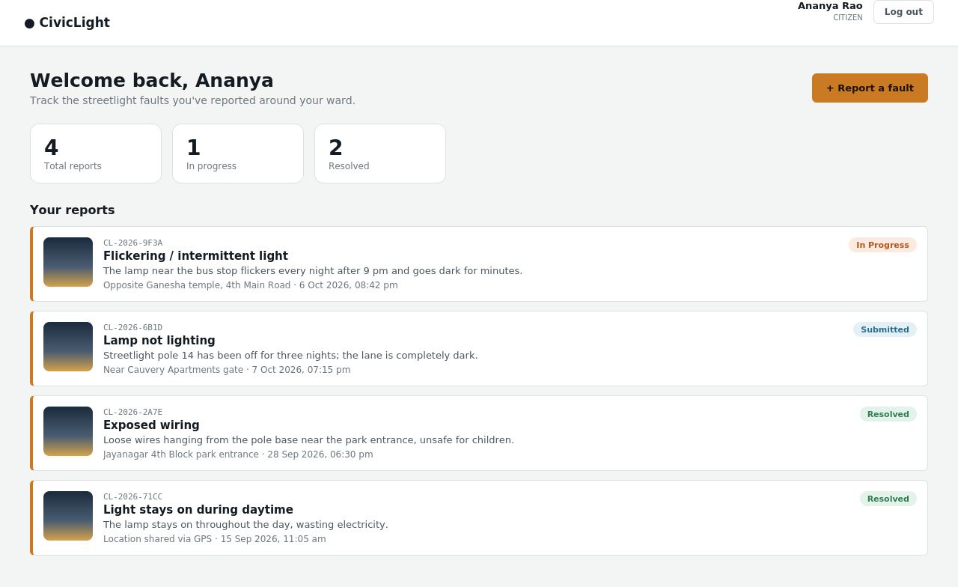
Fig. 6.1 Citizen Dashboard
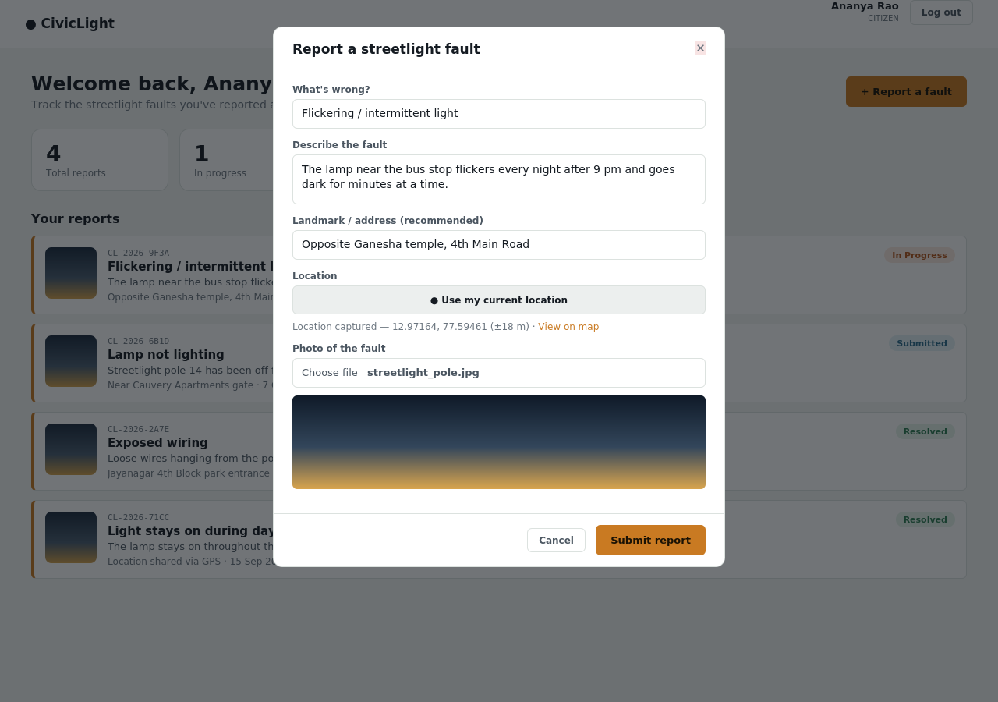
Fig. 6.2 Report a Fault — Form View
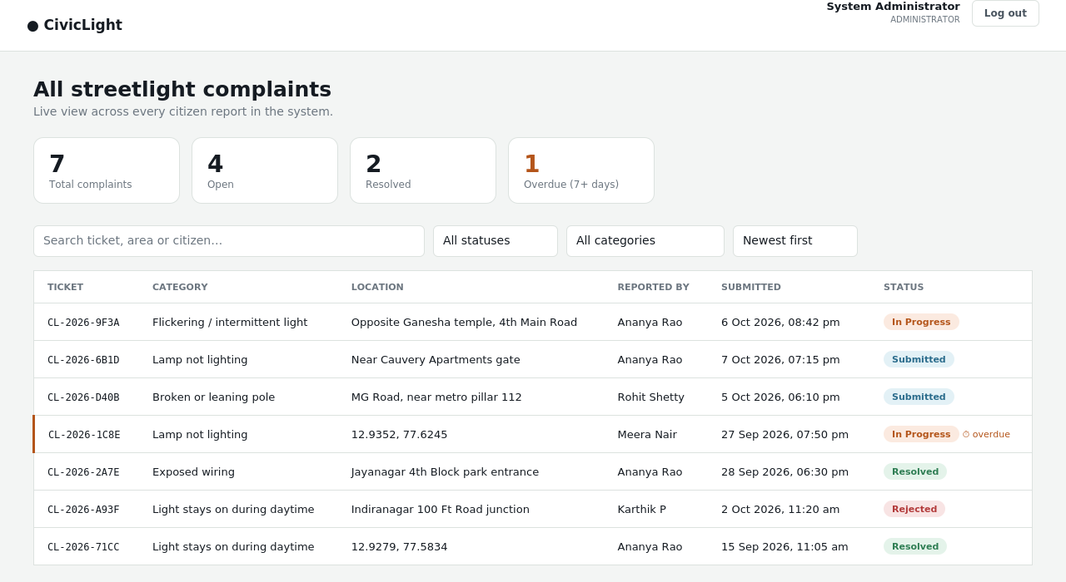
Fig. 6.3 Administrator Dashboard
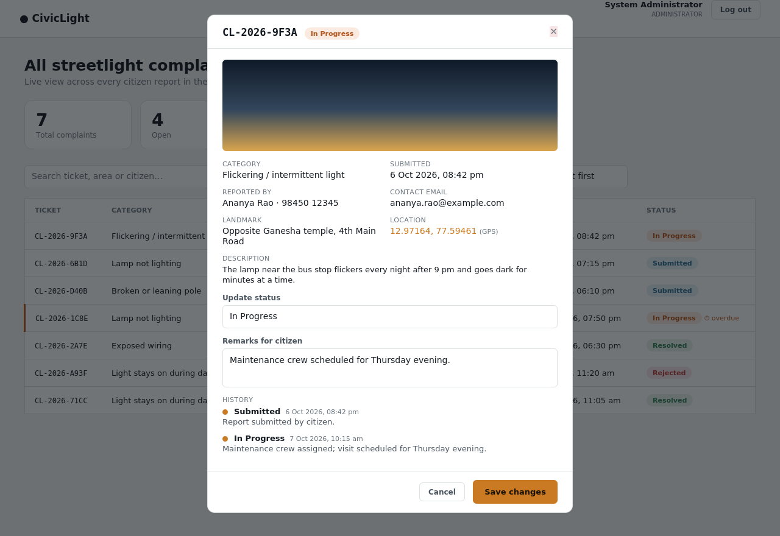
Fig 6.4 Complaint Detail and Status Update View

6.3 Discussion
Testing confirmed that the system meets the objectives set out in Section 1.3: citizens can file a report with photographic and location evidence in under a minute, every report is immediately visible to the administrator without a manual sync step, and status changes are reflected back to the citizen in real time, giving both sides visibility that the existing, manual process (Section 3.1) does not provide.
Two limitations were noted during development. First, password hashing is performed on the client side for simplicity; a production deployment would move this to a server-side authentication service. Second, the Geolocation API can be blocked by certain browser or network configurations, which is why a manual location fallback was built into the reporting form rather than making GPS capture a hard requirement.

CHAPTER 7
CONCLUSION AND FUTURE WORK
7.1 Conclusion
CivicLight successfully bridges the gap between citizens and municipal administrators for streetlight maintenance. By combining photo evidence, GPS geotagging and a live, two-way tracking workflow, the system replaces an opaque, manual complaint process with one that is fast, transparent and accountable. Testing confirmed that all stated objectives — role-based access for citizens and administrators, photo-and-location based reporting, centralised complaint tracking, and real-time status synchronisation — were met.

7.2 Future Enhancements
- SMS and email notifications to citizens at each status change.
- An analytics dashboard to identify recurring fault "hotspots" across the city.
- Integration with IoT-based streetlight sensors (Section 2.1) to combine automatic fault detection
with citizen reporting.
- A dedicated mobile application alongside the current web interface.
- Multi-language support to widen accessibility across the ward.

REFERENCES
[1] Mozilla Developer Network, "Geolocation API," MDN Web Docs.
Available: https://developer.mozilla.org/en-US/docs/Web/API/Geolocation_API

[2] W3C, "Geolocation API Specification," World Wide Web Consortium.
Available: https://www.w3.org/TR/geolocation/

[3] S. Maheswaran, R. D. Gomathi, S. Poovizhi, et al., "Centralized Monitoring System: Street Light Fault Detection and Location Tracking for Smart City," Proc. 1st Int. Conf. on Electronics, Computing, Communication and Control Technology (ICECCC), IEEE, 2024.

[4] L. J. Varghese, S. R. Prasath, M. Rahul, and E. Rathi Prabha, "Energy-Efficient Smart Street Lighting with Fault Detection and Real-Time Monitoring," Proc. 8th Int. Conf. on Inventive Computation Technologies (ICICT), IEEE, 2025.

[5] A. T. M. M. M. Chowdhury, J. Sultana, and M. S. U. Sourav, "IoT-Based Efficient Streetlight Controlling, Monitoring and Real-Time Error Detection System for Smart Cities in Bangladesh," Proc. 3rd Int. Conf. on Electrical, Computer and Communication Engineering (ECCE), 2023.

[6] F. Shama, A. Aziz, and L. B. M. Deya, "CitySolution: A Complaining Task Distributive Mobile Application for Smart City Corporation Using Deep Learning," arXiv:2410.12882, 2024.
Available: https://arxiv.org/abs/2410.12882

[7] Bruhat Bengaluru Mahanagara Palike (BBMP), "Sahaaya — Citizen Grievance Redressal Portal," bbmp.sahaaya.in.

